

Microsoft® Application Approval Workflow

Administrator’s Guide

Version 1.0

Published: April 2012

For the latest information, please see [www.microsoft.com/solutionaccelerators](http://www.microsoft.com/solutionaccelerators)

This document is provided "as is." Information and views expressed in this document, including URL and other Internet website references, may change without notice.

Some examples depicted herein are provided for illustration only and are fictitious. No real association or connection is intended or should be inferred.

This document does not provide you with any legal rights to any intellectual property in any Microsoft product. You may copy and use this document for your internal, reference purposes. You may modify this document for your internal, reference purposes.

© 2012 Microsoft Corporation. All rights reserved.

Microsoft, Active Directory, SQL Server, and Windows are trademarks of the Microsoft group of companies. All other trademarks are property of their respective owners.

Revision History

|  |  |
| --- | --- |
| Release Date | Changes |
| April 2012 | First release of this guide. |

Contents

Overview 1

Introduction 1

Prerequisite Concepts 2

Guide Workflow 3

Installation Prerequisites 3

Environment Prerequisites 3

Security Prerequisites 3

Other Prerequisites 4

For Support 4

Rollback Procedures 4

Installation 5

Install Application Approval Workflow (Part 1) 5

Install Application Approval Workflow (Part 2) 10

Uninstall Application Approval Workflow 16

Uninstall Application Approval Workflow from Orchestrator Server 16

Uninstall Application Approval Workflow from Service Manager Server 17

Repair Application Approval Workflow 18

Before You Proceed 20

Application Approval Workflow Resources 20

Configuration 21

Runbook Configuration 21

**Create and Synchronize the Connector** 22

How to Create an Active Directory Connector 22

How to Create an Orchestrator Connector 22

How to Synchronize a Connector 22

Verify Application Synchronization, Templates, and Users 23

How to Verify Initial Application Synchronization 23

How to Verify That There Is a Template 23

How to Verify That There Are Users 23

Create and View Application Approval Workflow Requests 23

How to View Application Approval Requests (Administrator) 24

How to View Application Requests (User) 24

How to View Applications Associated with Approval Requests 24

How to Create Application Approval Requests 25

How to Approve Application Approval Requests 25

How to Deny Application Approval Requests 25

Create, Rank, and Edit Selection Criteria 25

How to Create Selection Criteria 26

How to Rank Selection Criteria 26

How to Edit Selection Criteria 27

How to Run a Selection Criteria Simulation 28

How to Create an Application Approval Workflow Request Template 28

How to Modify an Existing Application Approval Workflow Request Template 29

How to Create a Copy of a Template 29

Deleting a Template 29

How to Manage Applications and Users as Groups 30

How to Create an Activity 30

Reports Configuration 30

How to view Application Approval Workflow Report in Data Warehouse 30

Appendix A: Personas and Scenarios 32

Appendix B: Troubleshooting 33

Troubleshooting Installer 33

Troubleshooting Runbooks 33

Troubleshooting Configuration 38

Appendix C: Tips and Tricks 39

# Overview

Microsoft® Application Approval Workflow (AAW) is a Microsoft Solution Accelerator for the Microsoft System Center 2012 platform. This solution enhances the Microsoft System Center 2012 Configuration Manager application approval process using Microsoft System Center 2012 - Service Manager service request templates, enabling flexible approver lists.

With AAW, enterprises can realize the benefits of infrastructure as a service while simultaneously using their existing investments in Service Manager, Microsoft System Center 2012 - Orchestrator, and Configuration Manager. Enabling a distributed application approval workflow process for System Center enhances the self-service experience.

## Introduction

IT organizations considering AAW need to examine and adapt their existing tools, processes, workflows, and automation to meet the requirements of an effective AAW implementation. Although it is critical that the underlying components (such as the Service Manager Portal, Service Manager request infrastructure, notifications, workflows, and automation) integrate well with each other and account for industry-wide best practices, the work involved to ensure an effective AAW implementation can be daunting and time-consuming. AAW addresses these concerns by allowing administrators to configure application requirements to meet their own needs.

In adopting AAW, enterprises can benefit from the existing features and functionality already available in the System Center suite. IT can tailor the solution to meet the needs of the business—for example, the Service Manager platform allows organizations to better manage application allocation and distribution. AAW enables administrators to add approval criteria to the process. For example, for the allocation of a specific application that has limited licenses, administrators can require manager approval before the application is distributed, allowing administrators to configure the application requirements accordingly.

The benefits AAW offers the enterprise include:

* A well-tested and fully supported AAW solution that accounts for industry-wide best practices
* Customization and extension of the AAW experience, natively supported by the System Center suite of products
* Reduced cost, effort, and time to deploy AAW to organizations that already use the System Center platform

The benefits that AAW offers consumers of IT within the enterprise include:

* Standardized and well-defined processes for requesting and managing application approval criteria
* Natively supported request, approval, and notification to enable businesses to effectively manage their own application allocation.

# Prerequisite Concepts

The goal of Service Manager is to support IT service management in a broad sense. This support includes implementing IT Infrastructure Library (ITIL) processes such as change management and incident management. It can also include other processes, such as allocating resources from a private cloud.

Service Manager maintains a *configuration management database*. This database is the repository for most configuration- and management-related information in the System Center 2012 environment.

When a user requests an application through the Configuration Manager Application Catalog that requires approval, this approval workflow solution transforms the application request into a Service Manager service request, allowing flexible approval lists and activities.

Service Manager starts a *workflow* to handle the request. It sends the user’s manager or appropriate approver a request, which the approver can approve or deny. If the request is approved, the workflow then starts an Orchestrator runbook.

A runbook is essentially another kind of workflow. Although a Service Manager workflow is designed to implement ITIL-style processes, a runbook is designed to interact directly with system management tools. Orchestrator provides a range of prebuilt components to interact with other technologies (including non-Microsoft management tools). The runbooks included in the solution are designed to interact with Service Manager. The runbook relies on Orchestrator components to ask Service Manager to create a new application approval request. AAW routes the request to the appropriate approvers using the Service Manager workflow capabilities.

# Guide Workflow

This guide helps Service Manager administrators:

* Install AAW
* Configure AAW
* Enable self-service requests in the Service Manager
* Help service providers fulfill AAW requests

Figure 1 shows the workflow for the steps described in this guide.



Figure 1. Application Approval Workflow

## Installation Prerequisites

Before installing AAW, ensure that you have met these prerequisites.

### Environment Prerequisites

* System Center 2012 - Service Manager
* System Center 2012 - Orchestrator
* System Center 2012 - Configuration Manager
* Microsoft Visual C++ 2010 x64 Redistributable – 10.0.30319

### Security Prerequisites

Installation of AAW:

* Service Manager:
* The person who installs Service Manager should be a member of the Service Manager Administrator role.
* Orchestrator:
* The person who installs Orchestrator should be an administrator in the Orchestrator database. (Local administrator privilege is required.)
* Configuration Manager:
* Security credentials are required for connecting to Configuration Manager.
* The ability to remotely access the Windows® Management Instrumentation (WMI) provider on Configuration Manager is required. You need to be added to a group that has access. How this is done depends on your environment setup (refer to [Authorize WMI users and set permissions](http://technet.microsoft.com/en-us/library/cc771551.aspx)).

Runbook Server:

* Orchestrator Runbook service
* Orchestrator Management service account
* The service account for the Orchestrator Management Service must have the following:
* Permission to log on to the management server as a service (This right is automatically granted during the installation process.)
* The service accounts are OrchestratorSystemGroup and OrchestratorUsersGroup
* Member of the Microsoft.SystemCenter.Orchestrator.Admins role in the Orchestrator database (The account is automatically added to this role during the installation process.)

### Other Prerequisites

* Configuration Manager—site name for Configuration Manager
* Service Manager—register the Data Warehouse
* Microsoft System Center Integration Pack for System Center 2012 Service Manager

### For Support

* Contact Microsoft Support at [http://support.microsoft.com](http://support.microsoft.com/).

### Rollback Procedures

AAW will be removed automatically if the setup fails when importing the Solution Accelerator. This removal will not affect the next installation.

# Installation

Use these procedures to install AAW. There are two parts to the installer. The first part should be installed on the Service Manager server; the second part should be installed on the Orchestrator server. Launch Application Approval Workflow Setup on the Service Manager server when complete. Launch the same Setup (Application Approval Workflow Setup) on the Orchestrator server.

## Install Application Approval Workflow (Part 1)

The installation of AAW on the Service Manager server installs the necessary management packs. The administrator can define the required application approval workflows to direct incoming application requests from the Configuration Manager Application Catalog.

1. Open the Microsoft Application Approval Workflow Setup Wizard, and click Install Application Approval Workflow components for Service Manager (see Figure 2).

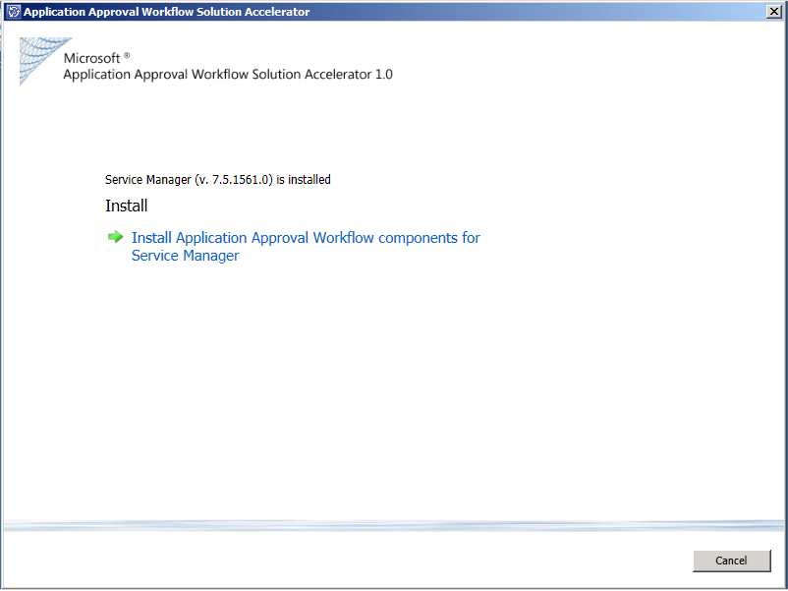

Figure 2. Install Application Approval Workflow components for Service Manager

1. On the Software License Terms page, read and accept the license terms, and then click Next (see Figure 3).

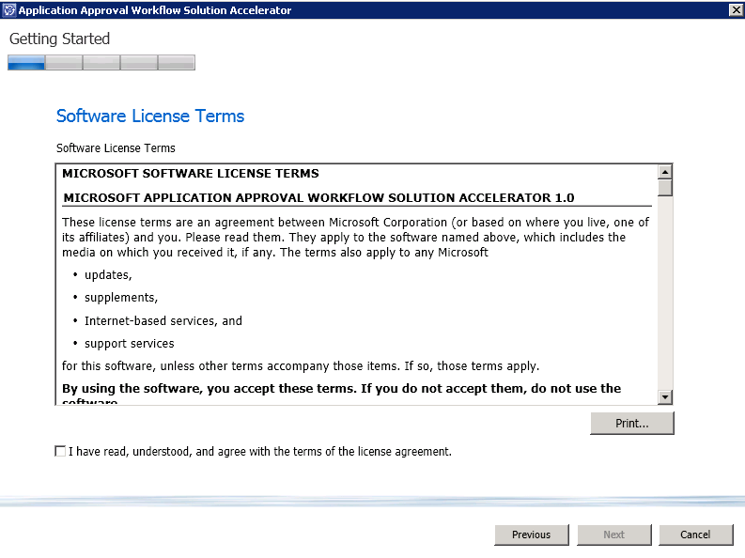Figure 3. Software license terms

1. On the **Installation Location** page, review and verify that the correct items are selected, and then click **Next** (see Figure 4).

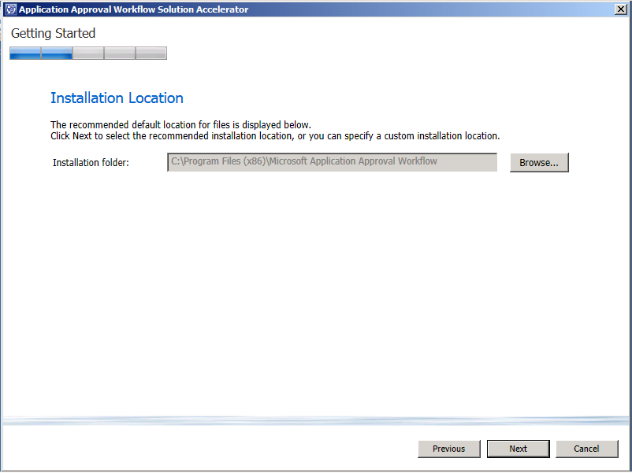

Figure 4. Installation Location

1. On the **Installation summary** page, click **Install** (see Figure 5).

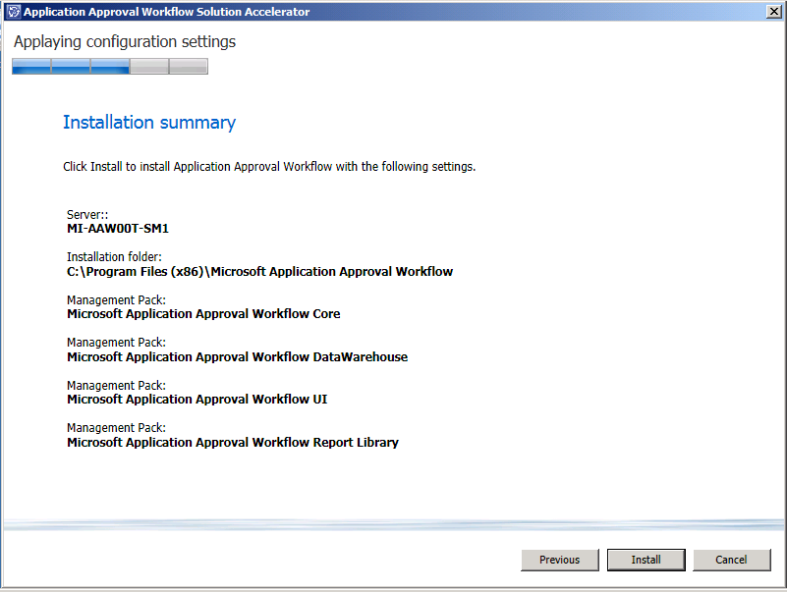

Figure 5. Installation summary

1. On the **Installation completed successfully** page, review the details of the installation, and then click Close (see Figure 6).

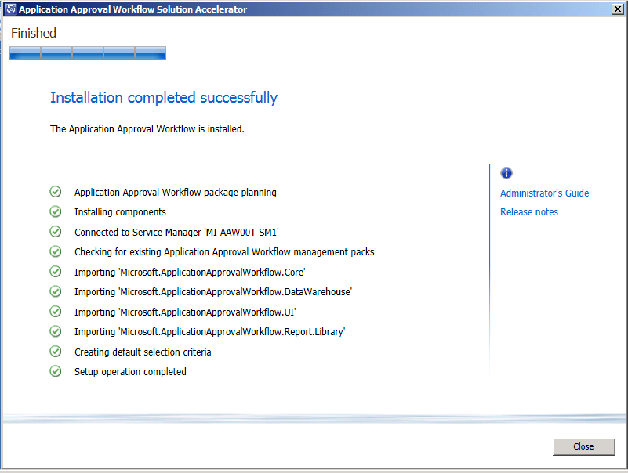

Figure 6. Installation completed successfully

## Install Application Approval Workflow (Part 2)

The installation of AAW on the Orchestrator server installs the necessary runbooks.

1. Open the Microsoft Application Approval Workflow Setup Wizard, and click Install Application Approval Workflow components for Orchestrator (see Figure 7).

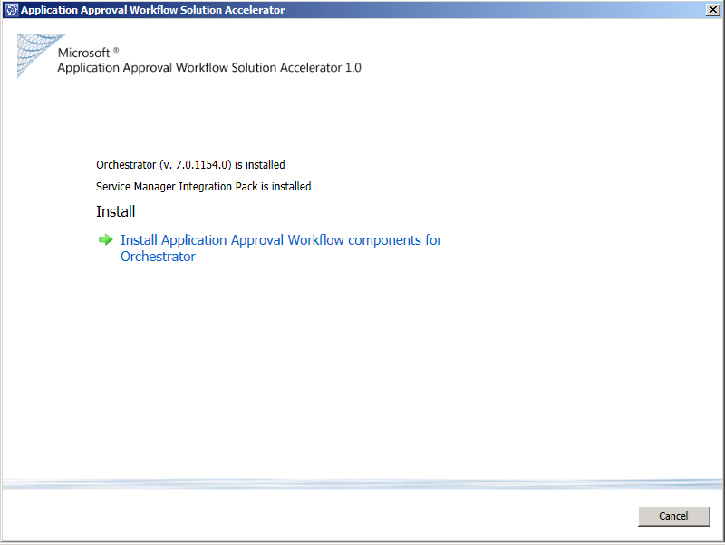

Figure 7. Install Application Approval Workflow components for Orchestrator

1. On the Software License Terms page, read and accept the license terms, and then click Next (see Figure 8).



Figure 8. Software License Terms

1. On the **Installation Location** page, review and verify that the correct items are selected, and then click **Next** (see Figure 9).

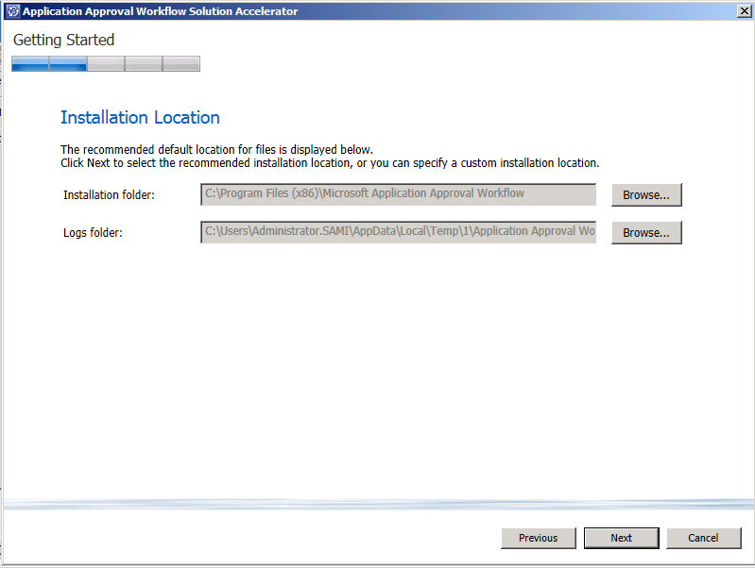

Figure 9. Installation Location

1. On the **Configuration Manager settings** page (Figure 10), provide the following information:

* **Configuration Manager Server Name**. The name of the Configuration Manager server
* User name. The name of the Configuration manager administrator
* **Password.** The password of the Configuration manager administrator account
* **Configuration Manager site code**

Determine the Configuration Manager site code:

* Open System Center 2012 Configuration Manager Console
* Click **Administration,** you will find Site Code under **Overview -> Site Configuration -> Site**

The next two values refer to the frequency with which Configuration Manager is polled for new requests:

* **Sync applications every.** Sixty minutes is the default, but the value depends on the frequency you require your organization’s applications to be pulled from the Configuration Manager server. The recommended time for a large organization is every 60 minutes.
* **Sync application requests every.** Thirty minutes is the default, but the value depends on the frequency you require your organization’s application requests to be pulled from the Configuration Manager server. The recommended time for a large organization is every 30 minutes.

Click Next.

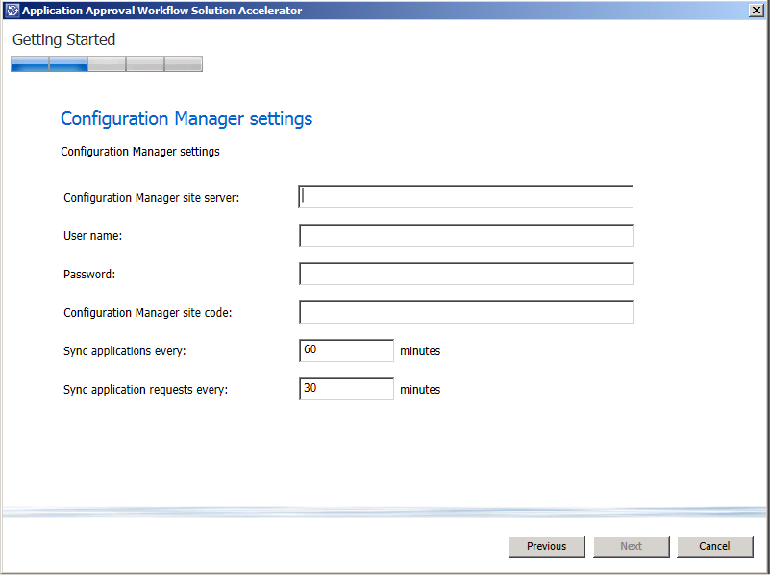

Figure 10. Configuration Manager settings

1. On the **Service Manager settings** page (see Figure 11), provide the following information:

* Service Manager Server. The name of the Service Manager server
* User name. The name of the Service Manager administrator
* Password. The password for the Service Manager administrator account
* Sync application requests every. Thirty minutes is the default, but the value depends on the frequency you require your organization’s application requests to be pulled from the Service Manager server. The recommended time for a large organization is every 15 minutes.

Click Next.

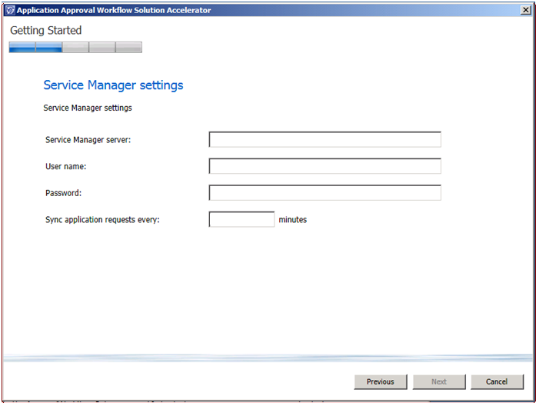

Figure 11. Service Manager settings

1. On the **Installation summary** page, click **Install** (see Figure 12).

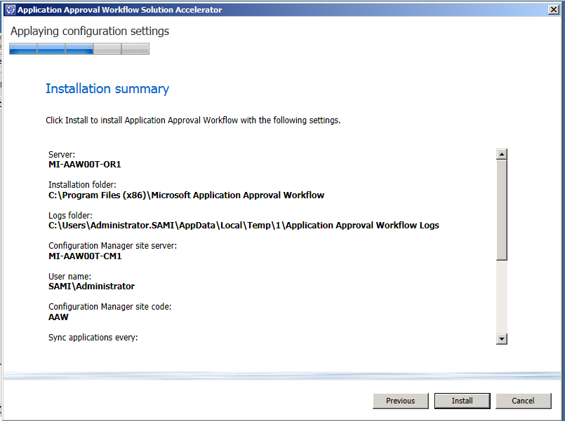

Figure 12. Installation summary

1. On the Installation completed successfully page (see Figure 13), review the details of the installation, and then click Close.

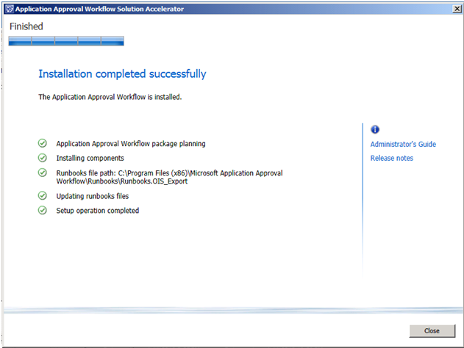

Figure 13. Installation completed successfully

# Uninstall Application Approval Workflow

## Uninstall Application Approval Workflow from Orchestrator Server

You can uninstall AAW from Control Panel. To do so, you must be an administrator on Orchestrator Server administrator.

On the **Uninstall or change a program** page, select AAW, and then click **Uninstall**, as shown in Figure 14.

Note: Before Uninstallation of AAW make sure to:

* Stop all running Application Approval Workflow runbooks
* Manually delete all Application Approval Workflow runbooks
* On the orchestrator Server the Wizard will be displayed as shown in Figure 14.  
    
  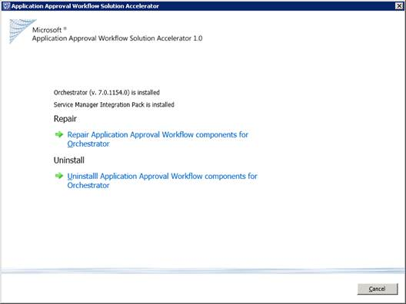
* Figure 14. Repair / uninstall AAW on Orchestrator Server

## Uninstall Application Approval Workflow from Service Manager Server

You can uninstall AAW from Control Panel. To do so, you must be an administrator on Service Manager administrator.

On the **Uninstall or change a program** page, select AAW, and then click **Uninstall**, as shown in Figure 15.

Note: Before Uninstallation of AAW make sure to:

* Delete the **Management Packs** that store the AAW templates
* Close all the AAW Consoles (Service Manager) and Documents (CHM files)

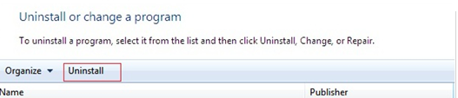

Figure 15. Uninstall AAW

# Repair Application Approval Workflow

You can repair AAW from the Control Panel. To do so, you must be an administrator on the machine on which the program is installed as well as a Service Manager administrator.

On the **Uninstall or change a program** page, select AAW, and then click **Uninstall**, as shown in Figure 16.



Figure 16. Repair AAW

And on the Service Manager Server the Wizard will be as shown in figure 17

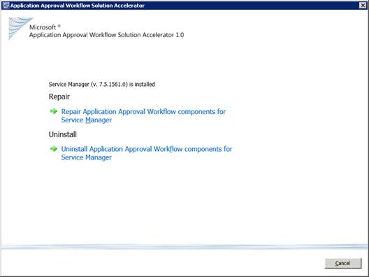

Figure 17. Repair / Uninstall AAW on Service Manager Server

By selecting **Repair Application Approval Workflow components for Service Manager**, the wizard will take you through the installer, excluding the Software License Terms page and repair the installation.

The **Repair** option on the Orchestrator server will re-deploy all AAW files and will create a new runbook file with the parameters provided by the user during the installation (replacing the old one). To verify Application Approval Workflow works fine, please delete the old runbooks and import the new ones.

The repair function on the Service Manager server will re-deploy all missing AAW management packs and files.

## Before You Proceed

AAW is used for configuration and management of AAW requests. The AAW resources—accounts, services, and connectors—must be created and configured before you start to set up selection criteria for applications.

### Application Approval Workflow Resources

Table 1 describes the AAW resources that must be created and configured in the infrastructure before you perform the procedures in the section, “Configuration,” later in this guide.

Table 1. Application Approval Workflow Resources

| Item | Description |
| --- | --- |
| Accounts | All accounts must be set up correctly. |
| Services | All services must be running and set up with the correct accounts. |
| Active Directory®/Service Manager connector | Connector from Active Directory Domain Services (AD DS) to Service Manager. |
| Orchestrator/Service Manager connector | Connector from Orchestrator to Service Manager. |

# Configuration

This section describes the steps that the administrator performs in Service Manager to enable AAW request scenarios. An administrator first creates the Active Directory connector. A connector imports data from System Center and/or AD DS to the Service Manager database. Connectors must import your users and groups.

## Runbook Configuration

After installing AAW, import and configure the Orchestrator runbooks.

To import runbooks

1. Log on to the Orchestrator server on which AAW was installed.
2. Open the Runbook Designer.
3. Navigate to the Runbooks node.
4. Right-click the node, and then click **Import**.
5. Browse to the runbooks folder in AAW_installation_folder (where AAW_installation_folder is the default location unless you installed the application elsewhere—generally, it is located in Program Files(x86)).
6. Select **Runbooks.OIS_Export** in the runbooks folder.
7. Click **Finish** in the Import Options Wizard.

The AAW runbooks are imported into the Runbook Designer.

To configure global settings

1. Navigate to the Variables node under **Global Settings**.
2. Review all the settings, and configure for your environment.
3. You may choose to enable logging under **Logging Settings** by setting **Enable Logging** to **True.**

For additional configuration settings, refer to Configuration Troubleshooting.

To start the runbooks

1. Open the **Runbook Designer**.
2. Navigate to the **Runbooks** node.
3. Navigate to and select the **Automation** node under **Application Approval Workflow**.
4. For each of the following **tabs**, click Run (the green arrow) in the top menu bar:

* Application Catalog Synchronization
* Application Request Synchronization
* Automation Monitor
* Poll Service Manager

**Note:**Make sure all four are started.

1. Close the Runbook Designer.

This step only needs to be performed once after installation. Going forward, the runbooks will continue to run on the scheduled intervals.

## **Create and Synchronize the Connector**

Use these procedures to create connectors using the Service Manager console. Connector data coming from external systems that are imported into the database can be edited using the standard Service Manager forms. This is not recommended when the external source is regarded as the master data source such as the application data objects coming in from Configuration Manager. Changes made in Service Manager to these application data objects will be overwritten by the synchronization process.

In this section

* Create an Active Directory connector.
* Create an Orchestrator connector.
* Synchronize a connector.

### How to Create an Active Directory Connector

Use the following procedure in Service Manager to create, validate, and confirm the status of an Active Directory connector to import user and group objects from AD DS.

**To create an Active Directory** **connector**

1. In the Service Manager console, click Administration.
2. In the Administration pane, expand Administration, and then click Connectors.
3. In the Tasks pane, under Connectors, click Create Connector, and then click Active Directory Connector.
4. Follow the instructions at <http://technet.microsoft.com/en-us/library/hh519597.aspx> to create an Active Directory connector.

### How to Create an Orchestrator Connector

Use the following procedure in Service Manager to create, validate, and confirm the status of an Orchestrator connector.

**To create an Orchestrator connector**

1. In the Service Manager console, click Administration.
2. In the Administration pane, expand Administration, and then click Connectors.
3. In the Tasks pane, under Connectors, click Create Connector, and then click Orchestrator Connector.
4. Follow the instructions at http://technet.microsoft.com/en-us/library/hh519779.aspx to create a connector.

### How to Synchronize a Connector

**To synchronize a connector**

1. In the Service Manager console, click Administration.
2. In the Administration pane, expand Administration, and then click Connectors.
3. In the Connectors pane, select the connector to synchronize.
4. In the Tasks pane, click Synchronize Now.

## Verify Application Synchronization, Templates, and Users

In this section

* Verify initial application synchronization.
* Verify that there is a template.
* Verify that there are users.
* Verify that there are AAW runbooks in the library.

### How to Verify Initial Application Synchronization

Use the following procedure to verify that the initial applications have been synchronized.

**To verify initial application synchronization**

1. In the Service Manager console, click Configuration Items.
2. In the Configuration Items pane, click Application Catalog.

In the Application Catalog area, verify that the applications are there. If they are not, in the Tasks pane, click Sync Now.

1. For additional assistance, see Appendix B: Troubleshooting.

### How to Verify That There Is a Template

Use the following procedure to verify that there is a template to create application approval requests.

**To verify that a template exists**

1. In the Service Manager console, click **Library**.
2. In the Library, click **Templates**.
3. Search for Application Approval Workflow Template or Management Pack. Microsoft recommends creating a new management pack.
4. If no template or management pack exists, create a template. For instructions on how to do so, see How to Create an Application Approval Workflow Request Template later in this guide.

### How to Verify That There Are Users

Use the following procedure to verify that there are users to create application approval requests.

**To verify there are users**

1. In the Service Manager console, click Configuration Items.
2. In the Configuration Items pane, click Users.
3. In the Users area, verify that the appropriate users are there. If you do not see the appropriate users, see Appendix B: Troubleshooting.

## Create and View Application Approval Workflow Requests

In this section

* View application approval requests (administrator).
* View application approval requests (user).
* View applications associated with approval requests.
* Create application approval requests.
* Approve application approval requests.
* Deny application approval requests.

### How to View Application Approval Requests (Administrator)

Use the following procedure to view application approval requests. The administrator performs these tasks in the Service Manager console.

**To view the status of application approval requests**

1. In the Service Manager console, click Work Items.
2. In the Work Items pane, click Application Requests.
3. Choose the appropriate category from the five categories of application requests listed to see the status of the request:

* All Active Application Requests
* All Approved Application Requests
* All Denied Application Requests
* All Failed Application Requests
* All Cancelled Application Requests

1. To open the form and view the details, double-click **Application Request**.
2. If you do not see the application requests, see Appendix B: Troubleshooting.

### How to View Application Requests (User)

Use the following procedure to view application approval requests. The user performs these tasks in the Configuration Manager Portal.

1. In the Software Center from the Start Menu, click Find additional applications from the Application Catalog**.**
2. On the Application Catalog page, select My Application Requests.
3. On the My Application Requests page, select the request to view, and then click VIEW HISTORY.

### How to View Applications Associated with Approval Requests

Use the following procedure to view applications associated with approval requests. Doing so can give you an idea of how often applications are requested to gauge high-volume application request generators.

**To view the history of application approval requests**

1. In the Service Manager console, click Configuration Items.
2. In the Configuration Items pane, click Application Catalog.
3. Under Application Catalog, click Applications Associated with Application Requests.
4. To open the form, double-click the appropriate application approval request.
5. On the application’s Properties page, click History to show all of the changes that have been made to an application approval request.
6. Click OK.

### How to Create Application Approval Requests

Use the following procedure to create application approval requests in Configuration Manager.

**To create application approval requests**

1. In the Configuration Manager Application Catalog, you will see a list of applications that are available and ready for installation. Select the application you want to request, and then click REQUEST.
2. You can find additional applications by clicking Find additional applications from the application catalog in Software Center**.**
3. In the Reason for application request (required) box, type the reason for your request, and then click SUBMIT.

After submitting, you will see the Your request has been submitted page.

### How to Approve Application Approval Requests

Use the following procedure to approve application approval requests in the Service Manager Portal.

**To approve application approval requests**

1. In the My Activities pane of SMPortal, click My Activities.
2. In the My Activities area, to view the details of an In Progress application approval request, click **Parent work item** then click See details. Under Default application request, click the green arrow to return to the My Activities page.
3. In the Select a reviewer check box, select your name, and then click Approve.
4. In the Enter comment box, type a comment, and then click Save.

After saving, you will see the approved date and a green check mark next to the reviewer’s name.

### How to Deny Application Approval Requests

Use the following procedure to deny application approval requests.

**To deny application approval requests**

1. In the My Activities pane of SMPortal, click My Activities.
2. In the My Activities area to view the details of an In Progress application approval request, click Parent work item then click the See details. Under Default application request, click the green arrow to return to the My Activities page.
3. In the Select a reviewer box, select your name, and then click Deny.
4. In the Enter comment box, type a comment, and then click Save.

After saving, you will see the denied date and a red X next to the reviewer’s name.

## Create, Rank, and Edit Selection Criteria

Administrators can define the approval criteria for applications to control who can be approved for AAW requests. Using the Selection Criteria Wizard, you can create custom templates with defined criteria. When a request comes in from Configuration Manager, depending on who the users are, the group of which they are a member, and what application is being requested, the request can be processed accordingly. Note that status for Selection Criteria must be set to Production.

In this section

* Create selection criteria.
* Rank selection criteria.
* Edit selection criteria.
* Run a selection criteria simulation.
* Create an AAW request template.
* Modify an existing AAW request template.
* Create a copy of a template.
* Manage applications and users as groups.
* Create an activity.

### How to Create Selection Criteria

Use the following procedure to create selection criteria for applications.

**To create selection criteria for applications**

1. In the Service Manager console, click Administration.
2. In the Administration pane, click Application Approval. Click Selection Criteria, and then click **Create Selection Criteria Wizard** in the Tasks pane.
3. The Create Selection Criteria Wizard opens.
4. On the Before You Begin wizard page, click Next.
5. On the General page:

* In the Name box, type a name—for example, type Selection Criteria for Development Applications.
* In the Description box, type a name—for example, type Selection Criteria for Development Applications.
* Next to the Template box, click Browse:
  + On the Select Template page, under Templates, select the template you want, and then click OK.

1. On the **Selection Criteria** page, click **Application**, and then click **Add**.
2. In the **Select objects** dialog box, Click **Add** and add the applications you want, and then click **Next**.
3. On the **Selection Criteria** page, click **Users**, and then click **Add**.
4. In the **Select objects** dialog box, Add the users you want, and then click **OK**.

Note   By selecting Include Application Objects, you can select Applications.

Note   By clearing the Include Application Objects check box, you are implying that this rule will apply only to user objects.

Note   By selecting Include User Objects, you can select users.

Note   By clearing the Include User Objects check box, you are implying that this rule will apply only to application objects.

Note   By selecting both Include User Objects and Include Application Objects, you are implying that this rule will apply to both application and user objects.

1. Click **Next**.
2. On the **Reviewers** page, to Add Approvers by clicking the **Add** button next to the “Approvers” grid
   * On the “Reviewer” pop-up window specify the desired approver and click **OK**
3. Click Next.
4. On the **Summary** page, verify the settings, and click **Create**.
5. On the **Completion** page, verify the results, and click **Close**.

### How to Rank Selection Criteria

Use the following procedure to rank selection criteria for applications.

To rank selection criteria for applications

1. In the Service Manager console, click Administration.
2. In the Administration pane, click Application Approval, and then click Selection Criteria.

* To increase the priority of the application approval, select the **selection criteria**, and then click **Increase Rank**.
* To decrease the priority of the application approval, select the **selection criteria**, and then click **Decrease Rank**.
* To move an application with the highest priority to the top, select the **selection criteria** and then click **Top Rank**.
* To move an application with the lowest priority to the bottom, select the **selection criteria**, and then click **Bottom Rank**.

1. Ensure that **Multi-select** is enabled.

### How to Edit Selection Criteria

Use the following procedure to edit selection criteria for application approval requests. In this scenario, a user will be deleted so that he or she will not be a match to request an application.

To edit selection criteria for application approval requests

1. In the Service Manager console, click **Administration**.
2. In the Administration pane, click **Application Approval**, and then click **Selection Criteria**.
3. In the Selection Criteria View pane, select the desired Selection Criteria.
4. In the Tasks pane, click **Edit Selection Criteria Wizard**.

The Edit Selection Criteria Wizard opens.

In one scenario, you can delete the users:

1. On the **Selection Criteria** page, click **Users**.
2. Under **User** column, select the user, and then click **Delete**.
3. In the **Would you like to delete selected items** dialog box, click **Yes**, and then click **OK**.
4. You can run another defined selection criteria simulation by following the steps in the section, How to Run a Selection Criteria Simulation

In another scenario, you can delete all users by clearing the **Include Users Objects** check box:

1. In the Service Manager console, click **Administration**.
2. In the Administration pane, click **Application Approval**, and then click **Selection Criteria**.
3. In the Selection Criteria pane, click the appropriate application.
4. In the Tasks pane, click **Edit Selection Criteria Wizard**.

The Edit Selection Criteria Wizard opens.

1. On the **Selection Criteria** page, click **Users**.
2. Under **User** column, select the user, and then click **Delete**. Repeat this step for all of the other users.
3. Clear the **Include Users Objects** check box.
4. In the **Would you like to delete selected items** dialog box, click **Yes**, and then click **OK**.
5. You can run another selection criteria simulation by following the steps in the section, How to Run a Selection Criteria Simulation

### How to Run a Selection Criteria Simulation

Use the following procedure torun a simulation for selection criteria. Doing so shows you whether the selection criteria for an AAW template and a user are a match. This is a helpful tool for the administrator in cases where users repeatedly request applications but the requests are not approved or processed.

To run a simulation for selection criteria for a user and an application match

1. In the Service Manager console, click **Administration**.
2. In the Administration pane, click **Application Approval**, and then click **Selection Criteria**.
3. In the Tasks pane, click **Run simulation**.
4. On the **Incoming Request** page, type the user’s name in the **User** box, or click **…**. to search for the user.
5. Next to the **Application** box, click **Browse**.
6. In the **Select objects** dialog box, select the application you want, and then click **OK**.
7. On the **Incoming Request** page, click **Run**.
8. In the **Microsoft Application Approval Workflow** dialog box, click **OK**.
9. On the **Incoming Request** page, click **Close**.

The Selection Criteria should have a status of **Test**. Select the Selection criteria, and in the Tasks pane, click **Change Status**.

1. In the **New Status** box, select **Production**, and then click **OK**.

Alternatively, you can change the status of an invalid template or a template that is not working correctly by selecting **Disabled** in the **New Status** box.

Note   Change the selection criteria status to Production if you want it to be used during request processing.

1. Click **Close**.

### How to Create an Application Approval Workflow Request Template

Use the following procedure to create an AAW request template.

To create an AAW request template

1. In the Service Manager console, click Library.
2. In the Library pane, click Templates.
3. Click Create Template.
4. On the Create Template page:
5. Type the new template name in the **Name** box.
6. Type the new template description in the **Description** box.
7. Next to the **Class** box, click **Browse**.
8. On the **Select a Class** page, under **All basic classes**, select **Application Request**, and then click **OK**.
9. If it is the first template you will be creating for AAW, next to **Management Pack**, click **New**.
10. On the **Create Management Pack** page:
11. Type the Management Pack name in the **Name** box.
12. Type the Management Pack description in the **Description** box, and then click **OK**.
13. Create an activity.

### How to Modify an Existing Application Approval Workflow Request Template

Use the following procedure to make changes to an existing AAW request template. In this scenario, a reviewer will be added and provided the ability to veto, validate, and review application approval requests. Best practice when creating templates is to keep the template details generic and, when you use the template in defining a specific workflow approval, add activities specific to the required approval tasks.

**Note: It is strongly recommended not to modify activities in an AAW template once linked to any Production Selection Criteria. It would lead to Application request synchronization failure.**

To modify an existing template

1. In the Service Manager console, click **Administration**.
2. In the Administration pane, click **Application Approval**, and then click **Selection Criteria**.
3. In the Selection Criteria view pane, select the Selection Criteria with the AAW request template you want to change.
4. In the Tasks pane, click **Edit Selection Criteria Wizard**.
5. In the Edit Selection Criteria Wizard, on the **General** page, click **Open**.
6. On the **Create Template** page, click **OK**.
7. On the **Service Request Template** page, click **Activities**.
8. Open the Review Activity.
9. Now you can modify the **Review Activities** to accommodate your specific scenario.

### How to Create a Copy of a Template

Use the following procedure to create a copy of an existing AAW request template. You can create baseline templates, for example, for all applications that require manager approval. After you create a copy of a template, modify the activities to apply the template to all of the applications or groups of applications. See the section, How to Modify an Existing Application Approval Workflow Request Template, to modify the activities of a template.

To create a copy of a template

1. In the Service Manager console, click **Library**.
2. In the Library pane, click **Templates**.
3. In the **Templates** area, select the template to copy.
4. In the Tasks pane, click **Duplicate**.
5. On the **Select management pack** page, click **OK**.
6. In the **Templates** area, select the template that was copied.

Notice that the old title remains but will have the word Copy appended to the title.

1. In the Tasks pane, click **Properties**.
2. On the **Create Template** page, in the **Name** box, type the new name of the template, and then click **OK**.

### Deleting a Template

Caution   By deleting a template, all selection criteria related to the original template will be invalid. Avoid deleting a template, if possible.

### How to Manage Applications and Users as Groups

You can create baseline templates to apply templates to all of your applications or groups of applications. Use this procedure to manage applications and users as groups rather than individuals.

To manage requests as groups

1. In the Service Manager console, click **Administration**.
2. In the Administration pane, click **Application Approval**, and then click **Selection Criteria**.
3. In the Selection Criteria pane, select the AAW request template you want to manage as a group of applications—for example, you might have a template named Selection Criteria for Development Applications.
4. In the Edit Selection Criteria Wizard, on the **Selection Criteria** page, under **Application tab**, select all of the applications, and then click **OK**.
5. In the **Would you like to delete selected items** dialog box, click **Yes**, and then click **Delete**
6. In the Edit Selection Criteria Wizard, on the **Selection Criteria** page, under **Application tab**, click **Add Group**, and then click **OK**.
7. On the **Select objects** page, select a group—for example, Developers Applications.
8. In the Edit Selection Criteria Wizard, on the **Selection Criteria** page, select **Include Users Objects**, and then click **Users**.
9. In the Edit Selection Criteria Wizard, on the **Selection Criteria** page, under **Users**, click **Add Group**, select the group of users you want to add, and then click **OK**.

### How to Create an Activity

You can create an activity for a template—for example, a Review activity that allows you to assign this task to individuals or a group for approval.

To create an activity

1. In the Service Manager console, navigate to **Library** and click on Templates.
2. In the View pane search and Select your application request template, click **Properties** and then click **“OK”** to open the application request template.
3. Navigate to the **Activities tab** of the Application request Template and click **Add.**
4. As an example, select Default **Review Activity**, and then click **OK.**
5. Provide a title for your review activity.
6. Review these options:

* If you want the line manager to approve, select **Line Manager**.
* If you want to define individuals, click **Add** in the Reviewers pane.
* Select **Reviewers**, and then click **OK**.

1. Review your approval condition.
2. Click **OK**, and then close the activity by clicking **OK**.

## Reports Configuration

User can view the reports in the Data Warehouse by following the instructions in the following sections.

### How to view Application Approval Workflow Report in Data Warehouse

You can view the application approval workflow reports in the Data Warehouse by following the below steps.

1. In Service Manager, click **Administration**.
2. In the Administration pane, click **Register with Service Manager Data Warehouse** to register Service Manager to Data Warehouse.
3. In Service Manager, click **Data Warehouse**, and then click **Data Warehouse Jobs**.
4. In the Data Warehouse Jobs pane, click **MPSyncJob**, and then click **Resume**.
5. After MPSyncJob finish, click **Data Warehouse**, then click **Management Packs**, verify the following management packs are deployed successfully.
6. **Microsoft Application Approval Workflow Core**
7. **Microsoft Application Approval Workflow Data Warehouse Library**
8. **Microsoft Application Approval Workflow Report Library**
9. **Microsoft Application Approval Workflow UI**
10. In Service Manager, click **Data Warehouse**, and then click **Data Warehouse Jobs**.
11. On Data Warehouse Jobs pane, click the following jobs in sequence.
12. **Extract_SMManagement_GroupName**
13. **Transform.Common**
14. **Load.common**
15. Now report data should be in the Application Approval Workflow Report.
16. Click **Reporting** wonderbar in Service Manager, and then click **Application Approval Workflow Report**. You can see all pending application requests and all approved\denied requests from here.

Note:

To make sure the Data Warehouse is working properly, on both Service Manager Server and Data Warehouse Server, add a new inbound rule in the Windows Firewall with Advanced Security with the TCPport 1433 for the SQL instance.

# Appendix A: Personas and Scenarios

This appendix defines the different personas, or roles, and responsibilities of those personas when using the Microsoft Application Approval Workflow Administrator’s Guide to create and manage AAW requests.

Consumer (User): Requests an application from the Configuration Manager Application Catalog.

Consumer (Approver): Approves or denies application requests from the Service Manager Portal.

Provider (Application Administrator):

1. Defines and maintains AAW criteria for specific:

* Applications or application groups
* Users or user groups

1. Assigns approvers—for example, a line manager who needs to provide approval
2. Reviews application approval requests in the Service Manager console
3. Manages, defines, and maintains AAW criteria templates:

* Reorders the sequence in which workflow approval criteria should be executed
* Creates default templates that can apply to multiple applications, application groups, users, or user groups
* Runs simulations before implementing criteria
* Allows additional templates and activities

# Appendix B: Troubleshooting

In this appendix

* Troubleshooting Installer
* Troubleshooting Runbooks
* Troubleshooting Configuration

## Troubleshooting Installer

This appendix provides some issues and solutions for the AAW installer

Issue: Installer failed, yet no error message was shown.

Details: Start by viewing the installation logs found at:

%TEMP%\Microsoft_Application_Approval_Workflow_<DateTime.log

%TEMP%\Microsoft_Application_Approval_Workflow_<DateTime><trycount >_AAWSetup.log”

## Troubleshooting Runbooks

This appendix provides some examples and solutions when trying to start the runbooks.

Issue: Runbook shows a WMI error.

Details:

A few of the runbook executions are stuck and not proceeding with the execution.

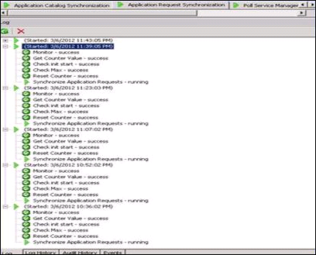

And when running the runbook, you get the following error in the logs:

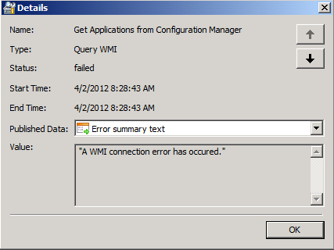

Solution: Verify that you can remotely access the WMI provider in Configuration Manager. You need to be added to a group that has access. This is environment specific, refer to [Authorize WMI users and set permissions](http://technet.microsoft.com/en-us/library/cc771551.aspx):

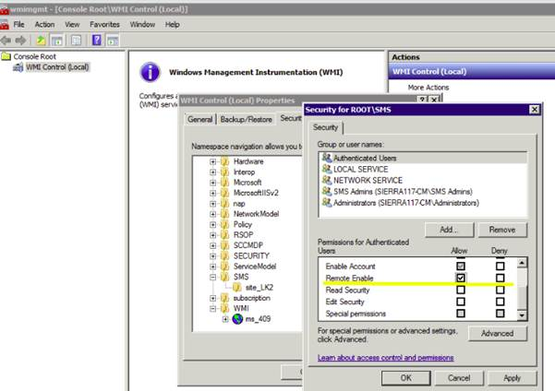

Issue: Runbook shows an object reference not set to an instance of an object.

Details: When running the runbook, you get the following error in the logs:

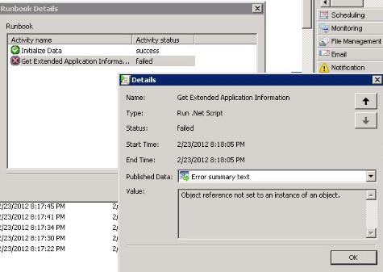

Solution: Verify that you have configured the firewall for WMI access. For more information, see [Connecting Through Windows Firewall](http://msdn.microsoft.com/en-us/library/aa389286.aspx).

Issue: Cannot start runbook ‘Create or Update Application instance in SM.’

Details: The specified account may be missing privileges required to invoke a runbook. Add the account to the Orchestrator System Group to give it the required authority:

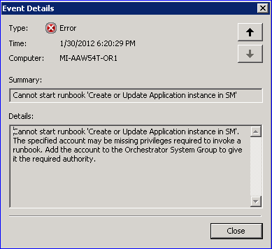

Reason: The runbook is trying to call another runbook. In this case, the account running this runbook is required to be a member of Orchestrator System Group.

Solution: Two groups are created under Server Manager\Configuration\Local Users and Groups\Groups during installation of Orchestrator server: one is Orchestrator System Group, and the other is Orchestrator User Group. Depending on your environment setup, the domain administrator is in Orchestrator User Group only. In Orchestrator System Group, only the service account Domain\Account is there.

To fix this problem, add the security account specified for this **Invoke Runbook** activity. To get the security account, find the failure “Invoke Runbook” activity, double click on it and go to “Security” page.

Issue: Warning: The object “Process Application Instance” in the policy “Create or Update Application instance in SM” failed.

Details: The user requested that this platform event be generated if the object fails:

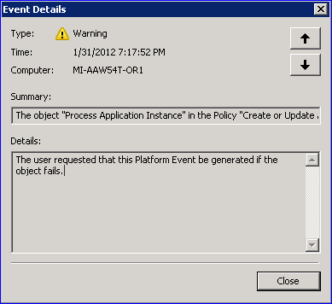

Reason: The running runbook activity has script -OPD_SMOperationResult = applicationCatalog.ProcessApplicationInstance(anInstance, out errorMessage).ToString().

The result returned from ProcessApplicationInstance is assigned to the OPD_SMOperationResult variable:

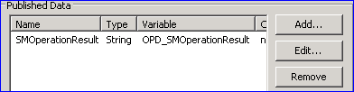

In the run behavior of that activity, the Report if the activity fails to run check box is selected. That is what “The user requested” means:

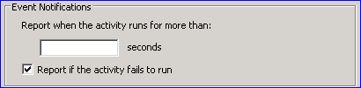

Solution: Verify whether assemblies included in the “Advanced” step are ready in a specified location (the custom SCO assembly folder). Debug from code, if necessary.

Issue: Warning: The policy “Create or Update Application instance in SM” failed.

Details: The user requested that this platform event be generated if the policy fails:

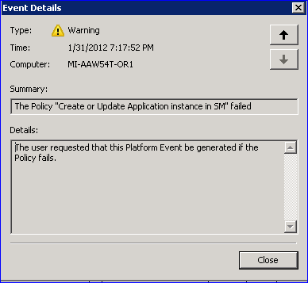

Reason: “Warning: The object ‘Process Application Instance’ in the policy ‘Create or Update Application instance in SM’ failed.”

Solution: Fix the failure from “Warning: The object ‘Process Application Instance’ in the Policy ‘Create or Update Application instance in SM’ failed.”

Issue: A few of the runbook executions are stuck and not proceeding with the execution.

Details: The runbook execution is in progress for a long time, and multiple runbooks are stuck at a particular step:

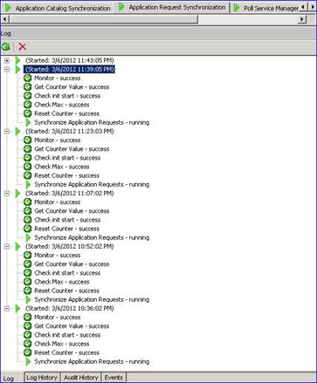

**Reason:** The problem is that the automation is queuing up application request synchronization instances, because previous instances have not yet finished. If (time to execute application request synchronization) > (application request polling frequency), then this will happen. In this situation, the number of queued automation runbook instances will rapidly grow (within its job concurrency settings).

**Solution:** Decrease polling frequency, use Microsoft SQL Server® configuration, use faster hardware, or provision an additional runbook server to spread the workload.

**Issue:** Unable to reset runbook counters.

**Details:** Orchestrator does not provide any way to reset the runbook counters.

**Solution:** AAW provides a way to reset the runbook counters. Open Runbook Designer, navigate to the Automation runbook, and then select the Reset Counters runbook, which resets all the counters for AAW.

## Troubleshooting Configuration

This section provides troubleshooting steps for configuration issues.

Issue: No logs are generated for the runbook execution.

Details: The logs for the runbook execution are not generated during the runbook execution.

Reason: Logging is not turned on in Runbook Designer.

Solution:

1. Navigate to the Global Settings node in Runbook Designer.
2. Verify the following settings under the Logging Configuration node:

* Verify whether EnableLogging and EnableVerboseLogging are set to True.
* Verify the LogFileLocation. The default location can be modified if you want the logs to be generated to a different place other than the one specified.

# Appendix C: Tips and Tricks

This appendix includes items that are good to know and that could save a call to the help desk:

* All approvers should be in the Service Manager Activity Implementers role.
* All approvers should be granted proper access to the Service Manager Portal.
* If the Service Manager Portal is not showing the Activities defined in approval request to the approver, make sure the approver has the correct privileges.
* Service Manager credentials and Configuration Manager credentials provided in the environment configuration must be a member of the Orchestrator System Group.
* The status of Selection Criteria must be Production. Selection Criteria with Test status is only for simulation purpose.
* After any AAW template is linked to selection criteria, it should not be deleted if the corresponding selection criteria is still in use. You will get unexpected results.